**Industry Project Report**

**on**

**Augmented Reality Integration for Enhanced Automotive Diagnostics**

|  |  |
| --- | --- |
| Developed by: | Guided by: |
| Isha Gohil (20162101020) | Prof. Kunal Garud (Internal Guide) |
|  |  |

Submitted to

Department of Computer Science & Engineering

Institute of Computer Technology



Year: 2024

**CERTIFICATE**

This is to certify that the Industry Project work with “Fixed Technologies” by Isha Gohil (20162101020) of Ganpat University, towards the partial fulfillment of requirements of the degree of Bachelor of Technology – Computer Science and Engineering, carried out by them in the CSE (Cloud Based Application) department. The results / findings contained in this project have not been submitted in part or full to any other university / institute for award of any other degree / diploma.

Prof. Kunal Garud

Place: ICT, Ganpat University

Date: May 3, 2023

**ACKNOWLEDGEMENT**

The industry project is a golden opportunity for learning and self-development. I consider myself very lucky and honored to have so many wonderful people lead me through in completion of this project. First and foremost, I would like to thank Dr. Rohit Patel, Principal, ICT, and Prof. Dharmesh Darji, Head, ICT who gave us an opportunity to undertake this project. My grateful thanks to Prof. Kunal Garud (internal guide) for their guidance in project work in Augmented Reality Integration for Enhanced Automotive Diagnostics, who despite being extraordinarily busy with academics, took time out to hear, guide and keep us on the correct path. We do not know where we would have been without his/her help. The CSE department monitored our progress and arranged all facilities to make life easier. We choose this moment to acknowledge their contribution gratefully.

Isha Gohil

20162101020

**ABSTRACT**

This report details the development and integration of an Augmented Reality (AR) API at Fixed Technologies, aimed at enhancing the visualization capabilities within automotive diagnostics. The project focused on creating a robust API framework that facilitates the overlay of digital information onto physical objects, specifically within the context of vehicle repair and maintenance. This integration aimed to provide technicians with real-time, enhanced visual data, improving accuracy and efficiency in diagnostics. The methodology involved the use of advanced AR tools and programming languages to develop and deploy the API. Key results demonstrated a significant improvement in diagnostic time and user satisfaction. This report evaluates the technical challenges, solutions implemented, and the potential for future enhancements in the AR field at Fixed Technologies

**TABLE OF CONTENTS**

|  |  |
| --- | --- |
| **Title** | **Page No** |
| **Chapter #01: Introduction** | **6** |
| **Chapter #02: Project Scope** | **7** |
| **Chapter #03: Project Workflow** | **8** |
| **Chapter #04: Implementation Details** | **10** |
| **Chapter #05: Work Plan** | **12** |
| **Chapter #06: Project Layout** | **13** |
| **Chapter #07: Progress** | **19** |
| **Chapter #08: Conclusion** | **23** |
| **References** | **24** |

**Chapter #01: Introduction**

Augmented Reality (AR) in automotive diagnostics is emerging as a pivotal technology, reshaping how technical data is interacted with and visualized. During my internship at Fixed Technologies, I was tasked with integrating AR capabilities into our existing API systems, a project aimed at augmenting traditional diagnostics with digital overlays that enhance precision and efficiency.

The project was initiated from a need to overcome the limitations of conventional diagnostic practices which were not only time-consuming but also susceptible to errors. The adoption of AR aimed to streamline these processes, offering real-time, enhanced visual feedback to technicians.

To achieve this, the project was structured to begin with the development of an AR-friendly API framework. This involved designing the system to interact seamlessly with AR devices and software, pulling data directly from our databases and overlaying it onto technicians' field of view in real-time.

This approach included extensive planning and development phases, starting with a rigorous collection and analysis of data needed to support AR functionalities. The system was carefully crafted to not only fetch and display data but also to interpret real-time inputs from technicians, enhancing their interaction with the machinery.

In deploying this technology, we expected not just to refine the process of automotive diagnostics but also to set a precedent for future innovations in the integration of AR within industry practices, aiming to significantly reduce diagnostic times and improve the accuracy of data interpretation and problem-solving in automotive technologies.

**Chapter #02: Project Scope**

The scope of this project includes the following:

1. **Data Integration:** Gathering and integrating extensive automotive data to support AR functionalities, ensuring high accuracy and relevancy.
2. **AR API Development:** Developing an API tailored for AR applications, enabling real-time data overlay directly onto vehicle components during diagnostics.
3. **System Testing and Optimization:** Rigorously testing the AR system within automotive diagnostics to refine functionality and performance.
4. **Initial Deployment and Feedback:** Launching the system in a pilot setting to collect user feedback, facilitating iterative improvements.
5. **End-User Documentation and Training:** Providing detailed documentation and training to technicians to maximize the usability and effectiveness of the AR features.

This project focuses on the development and initial implementation phases, excluding long-term maintenance or updates of the AR system, which will be managed by ongoing operations at Fixed Technologies.

**Chapter #03: Project Workflow**

**Preparation and Planning:**

* **Needs Assessment**: Conduct thorough discussions with stakeholders to understand the diagnostic challenges and requirements.
* **Technology Review**: Evaluate existing AR technologies and APIs to select appropriate tools and frameworks.
* **Project Blueprint**: Develop a detailed project plan including timelines, resources, and specific deliverables.

**Development Phase:**

* **Data Collection:** Assemble necessary data from various internal and external sources. This includes vehicle diagnostics data, user interaction logs, and more.
* **API Development**: Design and build the AR API to fetch, process, and overlay data on live video feeds from diagnostics tools.
* **AR Interface Design:** Create user-friendly AR interfaces that technicians can use to view diagnostic data overlaid on physical components.

**Testing and Integration:**

* **Unit Testing**: Test individual components of the API and AR interfaces to ensure they function correctly in isolation.
* **Integration Testing**: Combine different system components and test them together to identify any integration issues.
* **User Acceptance Testing (UAT**): Engage end-users to test the system in real-world scenarios and gather feedback.

**Implementation and Deployment**:

* **System Setup**: Configure the AR system within the existing technical infrastructure of Fixed Technologies.
* **Pilot Testing:** Roll out the feature in a controlled environment to monitor its performance and gather initial feedback.
* **Iteration:** Based on feedback, make necessary adjustments to improve functionality and user experience.

**Launch and Monitoring:**

* **Full-Scale Deployment:** Following successful pilot testing and final adjustments, fully integrate the AR API into daily operations.
* **Ongoing Monitoring:** Continuously monitor the system for any issues and update it as needed to ensure optimal performance.

**Documentation and Training**:

* **Documentation**: Compile comprehensive documentation covering all operational aspects of the AR system.
* **Training Sessions**: Conduct training programs for technicians to efficiently use the new AR diagnostic tools.

A schematic workflow diagram of the same is as illustrated below indicating the flow of the project.

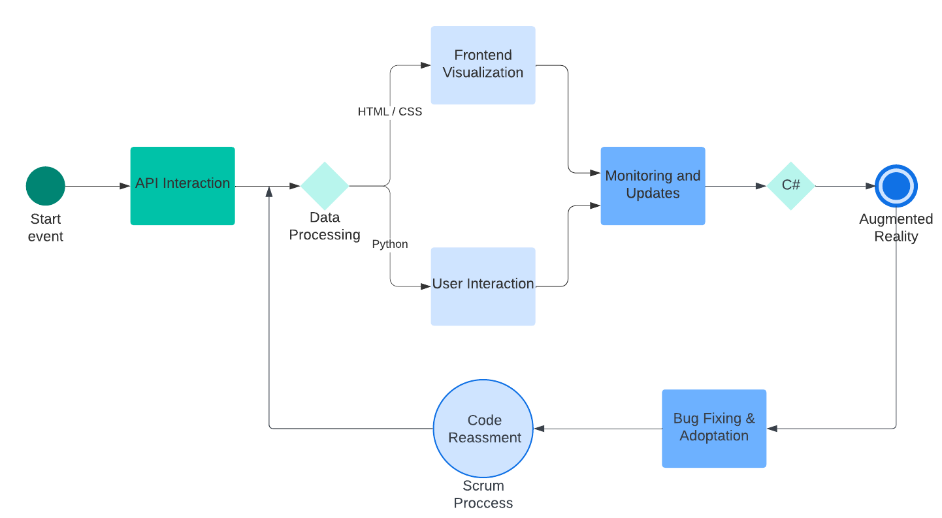

*Figure #01: Project Workflow Diagram*

**Chapter #04: Implementation Details**

The implementation of the Augmented Reality (AR) API at Fixed Technologies was a multi-faceted process, designed to enhance the precision and efficiency of automotive diagnostics. Here's a detailed look at the implementation stages:

1. **API Development :**

* **Framework Selection**: Chose robust AR frameworks and API technologies that align with real-time data processing needs.
* **API Coding**: Developed the AR API to fetch, process, and transmit automotive diagnostic data efficiently.
* **Security Implementation**: Integrated advanced security measures to ensure data integrity and privacy.

1. **AR Interface Design:**

* **User Interface Design**: Created intuitive and user-friendly AR interfaces, allowing technicians to interact with digital overlays on physical vehicle components.
* **User Experience Testing**: Conducted iterative design sessions with end-users to refine the interface based on real-world usability.

1. **System Integration**:

* **Hardware Integration**: Ensured compatibility with existing diagnostic hardware and AR display devices, like glasses or handheld units.
* **Software Compatibility**: Configured the API to seamlessly integrate with the company’s existing diagnostic software systems.

1. **Testing and Quality Assurance**:

* **Performance Testing**: Rigorous testing to assess the API and AR system performance under various operational conditions.
* **Bug Fixes and Optimizations**: Identified and resolved any technical issues, optimizing the system for better reliability and speed.

1. **Deployment:**

* **Initial Rollout**: Launched the system in a pilot program within selected departments to monitor its effectiveness.
* **Feedback Incorporation**: Adjusted the system based on technician feedback to enhance functionality.

1. **Training and Documentation**:

* **Documentation Creation:** Produced detailed user manuals and system documentation for ongoing support.

This structured approach ensured a smooth transition from traditional diagnostics to an enhanced AR-driven methodology, paving the way for broader adoption and further innovations in the field.

**Chapter #05: Work Plan**

Our work plan for developing the Augmented Reality and API Adapters includes the following steps:

| Outlined Work | Status | Timeline |
| --- | --- | --- |
| Initial Concept Development | Finished | Jan (week 1 - 2) |
| Technology Assessment | Launched | Jan (week 3) |
| API Design and Prototyping | Launched | Jan (week 4) - April (week 2) |
| AR Interface Design | Finished | March (week 3) - April (week 2) |
| Integration of AR with API | Finished | April (week 2 - 3) |
| System Testing | Finished | April (week 4) |

*Table #01: Work Plan*

**Chapter #06: Project Layout**

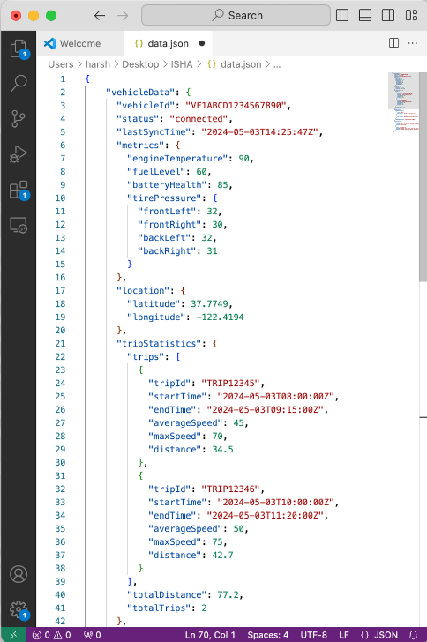

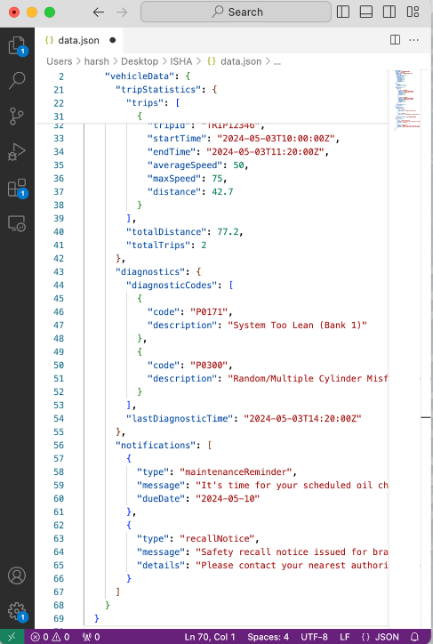

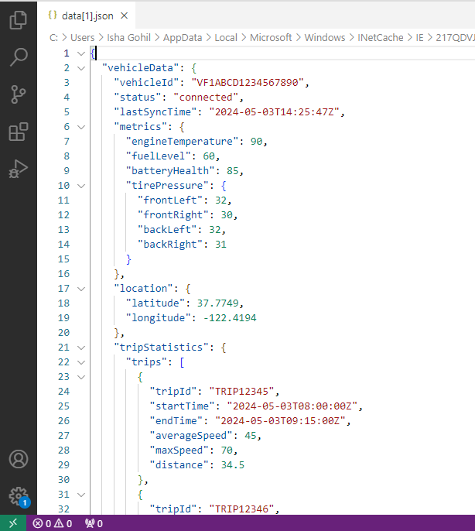

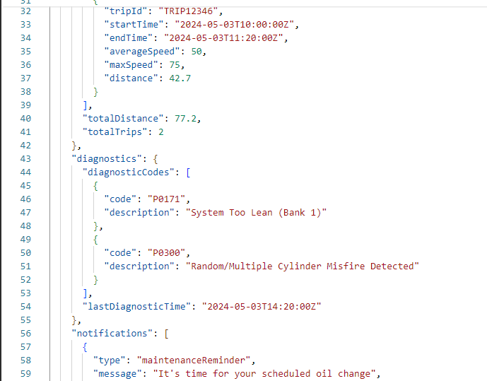

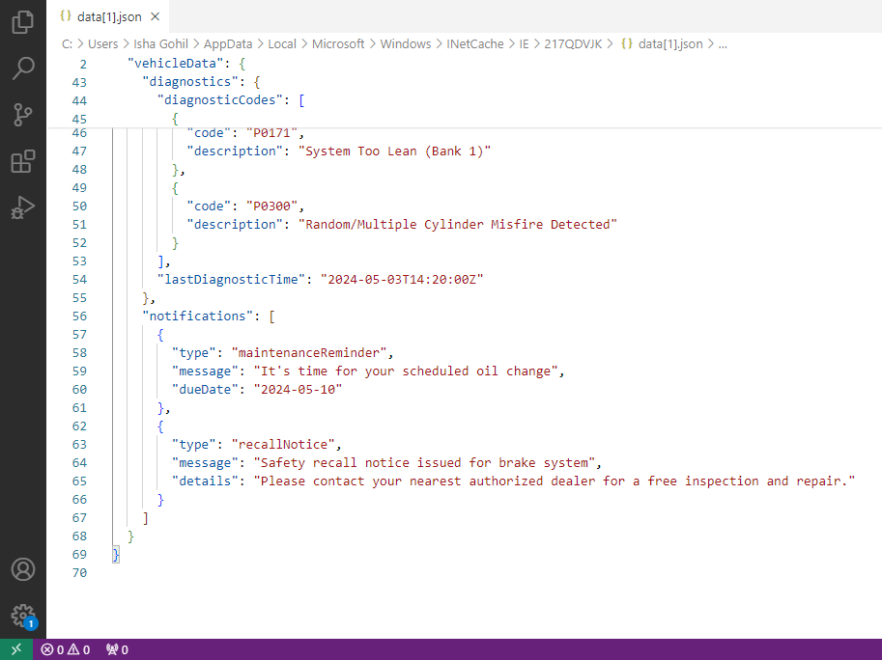

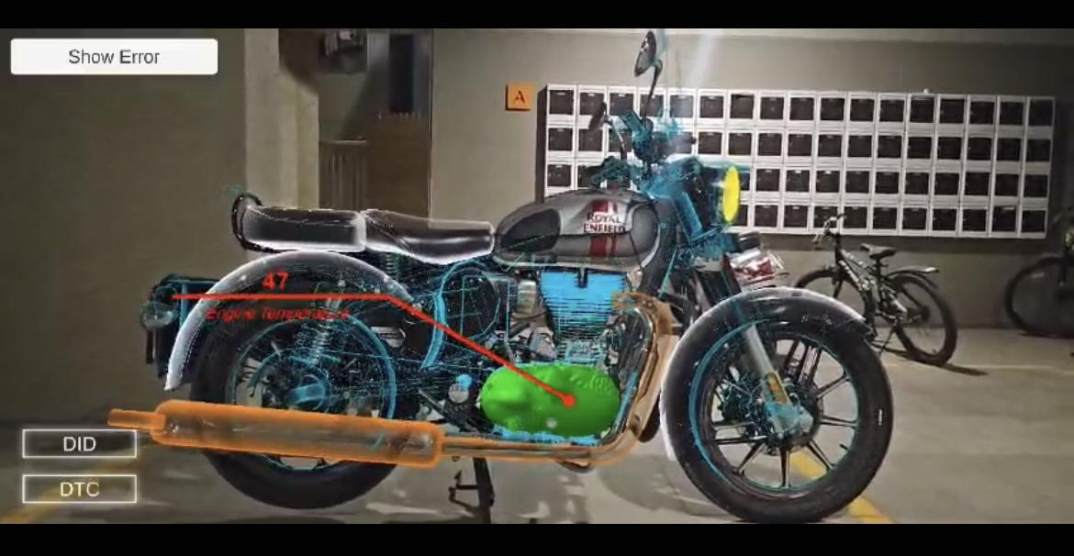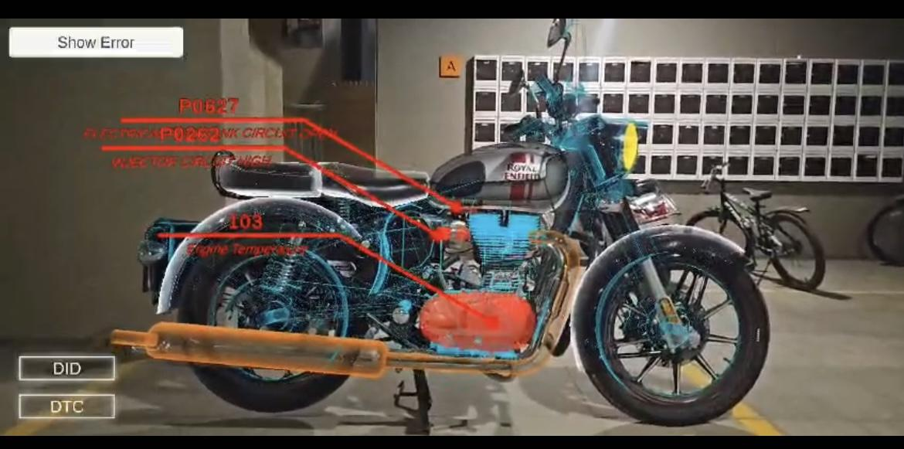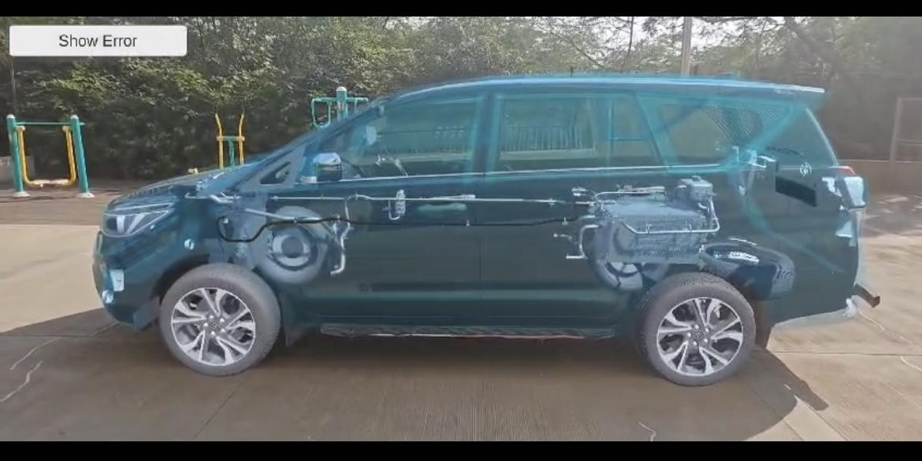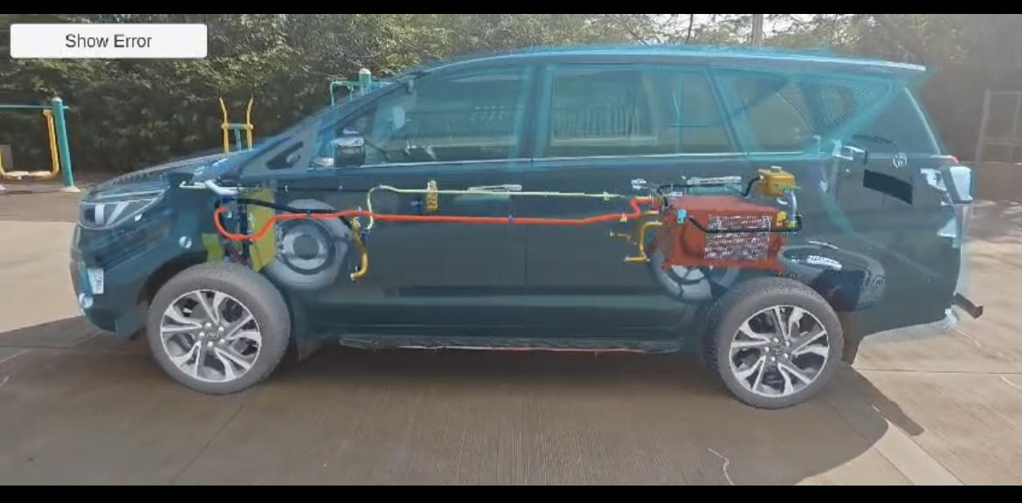

**Chapter #07: Project Progress**

**Phase #1 | January**

In January, the focus was on establishing a strong foundation for the Augmented Reality (AR) API project. The month began with detailed project kickoff meetings, where the scope and goals were defined in collaboration with various stakeholders. Extensive research and evaluation of AR platforms and API technologies were conducted to select the most suitable options based on compatibility, performance, and ease of integration. The latter part of the month saw the start of API and AR prototyping, utilizing Python and Unity respectively, to create initial models that were essential for early testing. Feedback loops were established to ensure that the development aligned with user needs and project objectives, paving the way for iterative design and development moving forward.

1. **Project Kickoff and Initial Meetings**: Conducted comprehensive meetings with stakeholders from IT, automotive diagnostics, and customer service to align on the project’s objectives and establish clear expectations.
2. **Defining Project Scope**: Formalized the project scope, outlining the integration of AR technology with existing diagnostic tools, anticipated enhancements in diagnostic processes, and the impact on user experience.
3. **Technology Evaluation**: Evaluated various AR platforms and API technologies, focusing on their compatibility with existing systems, performance metrics, and support for future scalability.

* Considered AR platforms like Vuforia for object recognition and Microsoft HoloLens for spatial mapping.
* Explored API frameworks, emphasizing RESTful architecture for its scalability and GraphQL for efficient data handling.

1. **Selection and Documentation**: Selected the most suitable technologies and documented the decision-making process, highlighting the benefits of each chosen technology and how they meet the project requirements.
2. **Prototype Development:**

* Initiated the development of the API using Python, leveraging its extensive libraries for robust and secure API construction.
* Began AR prototyping with Unity, creating initial simulations to demonstrate the overlay of diagnostic data on real-world objects.

1. **Early Testing and Stakeholder Feedback**:

* Conducted preliminary testing of the initial prototypes to identify functional issues or gaps in the initial designs.
* Engaged with stakeholders through presentations and demos to collect feedback, ensuring the project remains aligned with user needs and business goals.

1. **Iterative Design and Development**: Incorporated feedback into the design and development process, refining prototypes and planning for more advanced stages of the project.

**Phase #2 | February**

1. **Enhanced Development of AR and API Capabilities**: Developers focused on refining the AR interface and enhancing API functionality to ensure a seamless integration. This included optimizing the algorithms for faster data processing and improving the user interface design for better interaction by incorporating user-centered design principles.
2. **Robust System Integration:** Efforts intensified to integrate the AR system with Fixed Technologies' existing diagnostic tools and backend databases. This step was pivotal to achieve real-time synchronization and data accuracy. Integration tasks also included setting up secure API endpoints for data transmission and configuring middleware to handle data flow smoothly between systems.
3. **Comprehensive Testing Regimen**: The project team implemented a robust testing strategy that encompassed:

* Unit Testing: To ensure individual components of the AR and API performed as expected.
* Integration Testing: To verify that new integrations worked seamlessly with existing systems without causing disruptions.
* System Testing: Conducted to evaluate the complete system’s performance under simulated real-world operational conditions.

1. **Iterative Feedback Loop**: Continued collaboration with end-users provided critical insights, leading to iterative improvements. Feedback sessions were structured to gather detailed user interactions and satisfaction levels, which were then analyzed to pinpoint areas for enhancement.
2. **Documentation and Reporting**: Updated all project documentation regularly to reflect the changes and developments. This included detailed reports on the testing phases, integration steps, and feedback incorporation, ensuring transparency and ongoing alignment with project goals.
3. **Preparation for User Acceptance Testing (UAT):** By the end of February, preparations were underway to begin User Acceptance Testing in early March. This preparation involved finalizing the test environments, setting up user training sessions, and ensuring all technical support materials were ready.

**Phase #3 | March**

1. **User Acceptance Testing (UAT):** The month began with extensive UAT where technicians employed the AR system in real-world scenarios, simulating daily tasks to evaluate its performance and user-friendliness. This phase was crucial to ensuring the system met operational requirements and user expectations.
2. **Detailed Feedback Collection and Analysis**: Feedback from UAT was meticulously gathered and analyzed. This process involved categorizing issues related to usability, functionality, and performance. The development team held regular meetings to review feedback and prioritize adjustments.
3. **System Refinement and Optimization**: Based on the insights gained from user feedback, significant enhancements were made to the system. These included:

* Interface Improvements: Redesigning some UI elements to be more intuitive and user-friendly.
* Performance Enhancements: Optimizing backend processes to improve data processing speeds and reduce latency.
* Visual Accuracy: Adjusting AR overlays to increase precision in real-world applications.

1. **Security Strengthening**: Additional security protocols were implemented to ensure robust data protection, focusing on encryption enhancements and secure data transfer mechanisms.
2. **Pre-Deployment Preparations**: Preparing for deployment involved rigorous final testing, completing compliance checks, and solidifying deployment logistics. Training materials for end-users were finalized, and support structures were established to provide ongoing assistance post-deployment.
3. **Documentation Finalization**: All project documentation was updated to reflect the final system specifications and changes made during the optimization phase. Comprehensive manuals and user guides were prepared to aid in training and support.

**Phase #4 | April**

1. **Final Deployment**: The system was deployed across selected operational units. This phase was carefully managed to ensure minimal disruption, with a step-by-step approach that allowed for real-time troubleshooting and adjustment.
2. **Intensive Training Program**: Comprehensive training sessions were provided, designed to familiarize all users with the system's functionalities. These sessions included detailed demonstrations of the AR interface and hands-on practice scenarios, aimed at boosting user confidence and proficiency.
3. **Immediate Post-Deployment Monitoring**: Following the rollout, the system was closely monitored to assess its integration with existing workflows and to quickly rectify any technical issues. This continuous monitoring helped to stabilize the system and ensure that it performed as expected in a live environment.
4. **Feedback Loop and Iterative Improvements**: Feedback was collected from end-users through surveys and direct observations. This feedback was crucial for identifying any areas where the system could be enhanced to better meet user needs. Quick updates and optimizations were made in response to this feedback to improve functionality and user satisfaction.
5. **Comprehensive Post-Deployment Review**: At the end of the month, a thorough review was conducted to evaluate the overall success of the deployment. This review assessed user adoption rates, system performance metrics, and user feedback to determine the project's impact and to plan future enhancements.

**Chapter #08: Conclusion**

The deployment and integration of the Augmented Reality (AR) API at Fixed Technologies marked a significant milestone in enhancing automotive diagnostics. This project's conclusion draws attention to the successful implementation and the robust user engagement it fostered. Throughout the deployment phase, meticulous attention to system stability and user feedback highlighted the system's effectiveness in real-world applications. The comprehensive training and continuous improvements made based on user feedback underscored the adaptability and user-centered design of the AR system. This project not only achieved its intended goals but also set a precedent for future technological advancements within the company. The lessons learned from this initiative are invaluable, providing a strong foundation for subsequent enhancements and innovations in AR applications.

**References**

1. Unity AR Foundation: This cross-platform framework supports AR development across major AR platforms like ARKit and ARCore, making it ideal for projects aimed at diverse device ecosystems. Unity provides extensive documentation and tutorials to get started with AR <https://docs.unity3d.com/Manual/AR.html>
2. WebXR API: For AR projects aimed at web applications, WebXR provides tools to create immersive AR and VR experiences directly in web browsers, which is useful for reaching a broader audience without requiring app downloads <https://www.oreilly.com>
3. Google ARCore: Similar to ARKit but for Android, ARCore supports AR development with features like environmental understanding, light estimation, and user interaction <https://developers.google.com/ar>
4. RealityKit and Reality Composer: Provided by Apple, these tools are designed to make it easier to create realistic and compelling AR experiences with photorealistic rendering and simple scene composition <https://developer.apple.com/augmented-reality/>.
5. Web-based AR development: Integrating AR into web development can reduce deployment barriers and enhance user experience. It's particularly useful for businesses looking to enhance online presence <https://appmaster.io>.
6. Augmented Reality App Development Guide by Ideausher: Provides a quick overview of the key stages in AR app development, including design, testing, and post-launch maintenance <https://ideausher.com>